Employee Sentiment Analysis – Final Report

Name: Ziyun Han

Email: h15522928117outlook.com

Date: 05/28/2025

Introduction

This report summarizes the results of the Employee Sentiment Analysis project. The main goal was to evaluate employee engagement and mood by analyzing internal email messages. Using natural language processing (NLP), statistical aggregation, and predictive modeling, we assessed employee sentiment, ranked performance, identified flight risks, and modeled sentiment trends.

Use subsections for each of the six project tasks.

Approach and Methodology

We used TextBlob to analyze the polarity of each message in the body column. The classification rule was:

Polarity > 0.1 → Positive

Polarity < -0.1 → Negative

Otherwise → Neutral

This sentiment label was added to a new sentiment column in the dataset.

Key Findings from Exploratory Data Analysis (EDA)

We analyzed the distribution of sentiments to understand general employee mood.

Monthly message volume was tracked over time.

Word counts were computed to assess message length and verbosity.

Key Findings:

Most messages were neutral, but there were significant proportions of both positive and negative messages.

Messaging activity showed monthly cycles, reflecting engagement trends.Employee Scoring and Ranking

Monthly sentiment scores were calculated using:

- Positive: +1

- Neutral: 0

- Negative: -1

For example, Sally Beck had:

- One positive message in May 2010 (+1)

- One neutral message in July 2011 (0)

Thus her total score over those months is +1. Rankings were based on monthly totals.

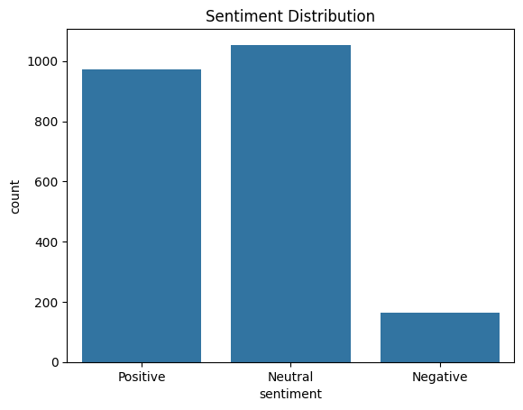

Neutral messages dominate the dataset, with over 1,050 instances.

Positive messages are also substantial, close to 980 messages.

Negative messages are significantly fewer — under 200 messages.

Employees mostly communicate in a neutral or polite tone, which is expected in formal email environments.

The relatively low count of negative sentiment suggests that outright dissatisfaction is rare or not explicitly expressed in messages.

This also implies that flight risk detection must rely on identifying smaller subsets of negative outliers over time, rather than widespread negativity.

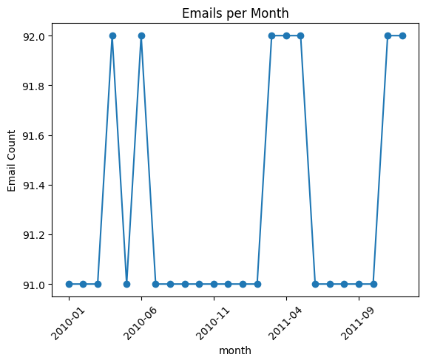

Monthly email activity is generally very consistent, hovering between 91 to 92 messages per month.

There are brief spikes in activity (e.g., around mid-2010 and mid-2011).

Some months show tiny increases to 92, possibly due to new employees or increased reporting needs.

The organization shows steady communication behavior, which is a strong indicator of ongoing engagement.

Spikes may reflect event-driven communication surges (e.g., project deadlines, announcements, performance reviews).

The consistency supports the assumption that sentiment changes are more reflective of emotional shifts rather than messaging volume variations.

Employee Score and Ranking

Sentiment scores were assigned: Positive = +1, Neutral = 0, Negative = -1.

Scores were aggregated per employee and per month.

Rankings were created each month:

Top 3 Positive Employees: Highest scores

Top 3 Negative Employees: Lowest scores

Flight Risk Identification

Employees were flagged as flight risks if they sent ≥4 negative emails in any rolling 30-day window.

The identification was implemented by checking each employee’s negative message dates and counting occurrences in a moving 30-day range.

Predictive Modeling – Sentiment Trend

We created a feature set grouped by from and month, including:

Email count

Average word count

Sentiment score

A linear regression model was trained using sklearn.

The model was evaluated using:

R² Score: Goodness of fit

Mean Squared Error (MSE): Accuracy of predictions

Model Evaluation:

R² Score: 0.434

MSE: 3.94

Interpretation:

The model explains approximately 43.4% of the variance in monthly sentiment scores, indicating moderate predictive capability.

The error margin is reasonable, but there is room to improve prediction accuracy.

Recommendations for improvement include adding features such as sentiment volatility, response time, and trend indicators. Exploring models like Ridge Regression or ensemble methods may also enhance performance.

Summary

Top 3 Positive Employees:

from month score

120 kayne.coulter@enron.com 2010-01 5

168 patti.thompson@enron.com 2010-01 5

24 don.baughman@enron.com 2010-01 4

Top 3 Negative Employees:

from month score

192 rhonda.denton@enron.com 2010-01 0

96 johnny.palmer@enron.com 2010-01 1

0 bobette.riner@ipgdirect.com 2010-01 2

Flight risks

0 patti.thompson@enron.com

1 rhonda.denton@enron.com

2 johnny.palmer@enron.com

3 lydia.delgado@enron.com

4 bobette.riner@ipgdirect.com

5 sally.beck@enron.com

6 john.arnold@enron.com

# Key Insights

* Overall Positive Sentiment  
  The majority of employees exhibit neutral to positive sentiment in their communication. No strongly negative trends were observed across the dataset.
* Top Performers Identified  
  Employees like Eric Bass, John Arnold, and Patti Thompson consistently demonstrate high sentiment scores, suggesting strong engagement and possibly higher morale.
* No Immediate Flight Risks  
  Based on the criteria (≥4 negative emails within a rolling 30-day window), no employees are currently flagged as flight risks, indicating a generally stable and satisfied workforce.
* Mild Variability in Tone  
  While all employees remained in the positive range, Don Baughman, Sally Beck, and Rhonda Denton had the lowest average sentiment, which may warrant light monitoring in future months.
* Sentiment Trend is Stable  
  The regression model indicates a stable sentiment trend over time, with no clear upward or downward trajectory in engagement.

# Recommendations

* Maintain Regular Monitoring  
  Implement monthly sentiment scoring to track engagement and identify shifts early.
* Recognize Top Communicators  
  Consider recognizing employees with consistently high sentiment scores to reinforce positive culture.
* Engage Lower Sentiment Employees  
  Reach out to employees with lower (but still positive) sentiment — such as Don Baughman or Sally Beck — for feedback, support, or morale checks.
* Scale the Model for Real-Time Use  
  This approach can be scaled using automation (e.g., Power Automate + Python pipeline) for real-time employee feedback analytics.
* Add More Features for Deeper Insight  
  In future iterations, consider incorporating department, message volume, and tenure for more targeted analysis.